“character goes the distance”
THE CHARACTER SERIES

grat·i·tude
Noun. The quality of being thankful; readiness to show appreciation for and to return kindness.
Gratitude is a social emotion. It is a relationship-strengthening emotion because it requires us to see how we’ve been supported and affirmed by other people.
It’s an affirmation of goodness. We affirm that there are good thing in the world, gifts and benefits we’ve received. This doesn’t mean that life is perfect; it doesn’t ignore complaints, burdens, and hassles. But when we look at life as a whole, gratitude encourages us to identify some amount of goodness in our life.
Robert A. Emmons, Ph.D., is the world’s leading scientific expert on gratitude and professor of psychology at the University of California, Davis.

ACTIVITIES
We would love to see how you do these with your family!
Tag us on Facebook or Twitter @characterplus
TRAVELING FAMILY GRATITUDE JOURNAL (Elementary-Adult)
Grab a notebook. Put a note in the front that you started this practice during COVID-19 and physical distancing, so you remember why/when you began.
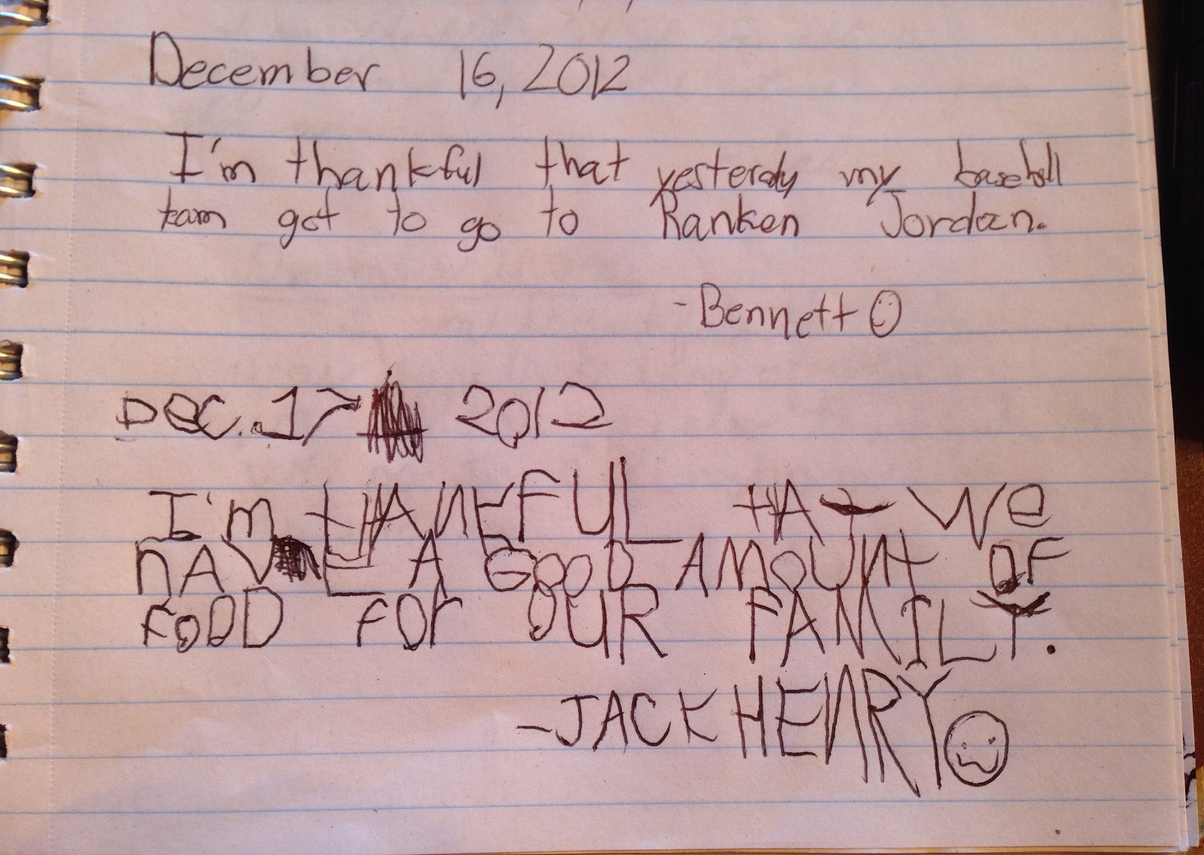
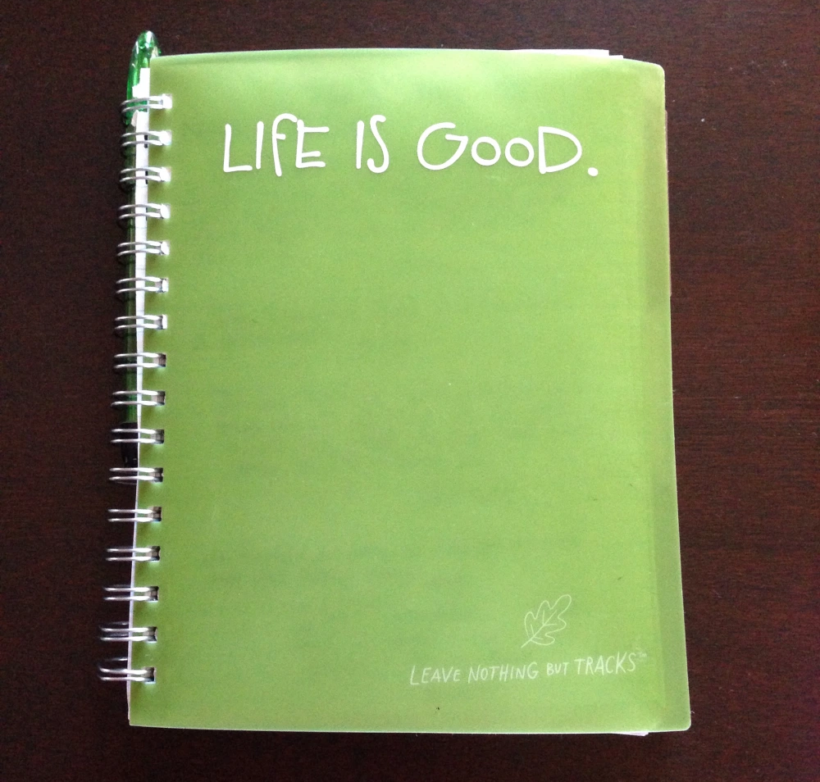
The idea is really simple: One family member writes down the date and something for which they’re thankful, and signs their name. Then, they leave the notebook at the bedside of another family member, who is responsible for writing in it within 24 hours and passing it to another family member.
Every day, there is something to be thankful for, even in times of great struggle, and kids (and adults, too!) often need practice seeing it. Also, by doing this, you’ll be creating a family artifact from this unprecedented time.

Our CharacterPlus® Way Director, Nicole Diehl, did this project with her own family several years ago.

WHY I’M GRATEFUL WORKSHEET (Elementary-Middle School)
This worksheet helps you find things you are grateful for, complete with prompts to get you started. These prompts cover multiple areas of life and dive deeper into your sense of gratitude.
The prompts include:
“I am grateful for my family because…”
“Something good happened this week…”
“I am grateful for my friendship with… because…”
“I am grateful for who I am because…”
“Something silly that I am grateful for…”
“Something else I am grateful for…”
Click here to find the worksheet. (Source: TherapistAid.com)
GRATITUDE COLLAGE (Early Childhood-Elementary)
If you're feeling crafty, try making a gratitude collage with your children. Grab some crayons, paper, glue, photos and magazine cut outs and have your children arrange items on a piece of paper. Talk about what items they chose and why they are grateful for them. . (Source: Investing in Children)
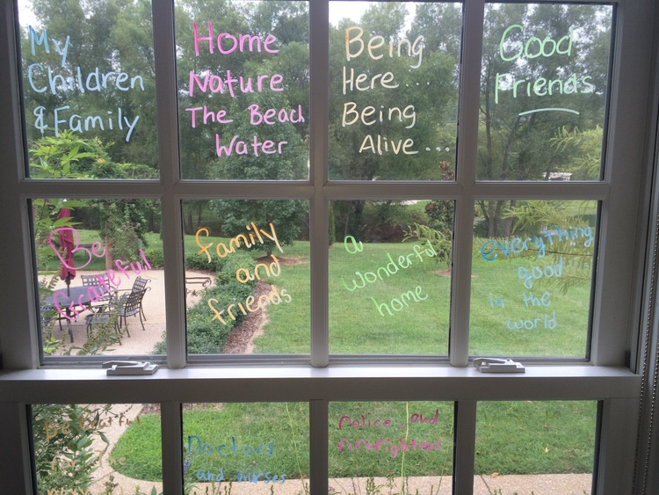
GRATITUDE WINDOW ART (Early Childhood-Elementary)
Do you have window markers? Put them to good use by having your children write what they are grateful for on a window in your house. If you have a paned window, you could give each section to a different family member (or just section out areas with the markers).
You could also express your gratitude for others (neighbors who are helping, your delivery people, the sanitation workers, etc.) by writing messages of thankfulness on your windows for them to see during this time of social distancing. (Source: Investing in Children)
MAKE IT A CONVERSATION (Early Childhood-Adult)
"What Would You Feel Without It" is conversation you can have with children of all ages. Simply ask what would they feel like without various items (which is especially appropriate right now!). They will be surprised how different life would be without some of the things they consider “normal.” You may also have a discussion about how other people live without such items, to help them remember to appreciate what is sometimes taken for granted in their life. (Source: Moments A Day)

ADDITIONAL RESOURCES

Psychology Today on Gratitude: What It Is, Why It Matters, and Cultivating It
The Science Behind Gratitude (and How It Can Change Your Life)
Gratitude Writing Prompts

